BAM Horizontal Logo

[](http://lawson.com/wcw.nsf/pub/GlobalStartPage)

“Employee Self Serve”

End-User Manual

**Table of Contents**

Introduction/How to Use this Manual ................................................................ 2

Lawson Portal Login ........................................................................................ 3

Lawson Navigation........................................................................................... 4

New Hire Section…........................................................................................... 6

Personal Information Section............................................................................ 7

Pay Section..................................................................................................... 8

Benefits Section............................................................................................. 9

Life Events Section.......................................................................................... 12

Employment Section.........................................................................................13

**Introduction**

**How to Use this Manual**

This manual uses the following text conventions and visual elements.

**Visual Elements**

|  |  |
| --- | --- |
| **THIS** | **REPRESENTS** |
| **BOLD** | Name of a key located on the keyboard e.g., **F1, Shift, Ctrl** |
| “ ” | Data the user must type |
| Underline | Buttons, Menus, Tabs, Links, or a List of Choices |
| [See full size image](http://willscullypower.files.wordpress.com/2009/12/tips.jpg) | Represents a tip for success |
| [See full size image](http://detectorsales.ca/Quickstart/ImageLib/help.jpg) | Represents Help or how to obtain help on this topic |
| [See full size image](http://www.creativemediaheroes.co.uk/images/eol-case-study/blue-globe2.jpg) | Represents system response or status information located in the lower left of the screen |
|  | Represents a warning |

**Lawson Portal Login**

**Process Basics**

Users access the Lawson system by logging onto http://my.bamm.com and then

selecting the Lawson link.

**Information Needed**

􀂅 Your Lawson User Name (Employee ID) and Password (zip + last four of SSN)

**Completing the Process**

􀂅 Go to the BAM! website: http://my.bamm.com

􀂅 Enter the information.

􀂅 Click on login.

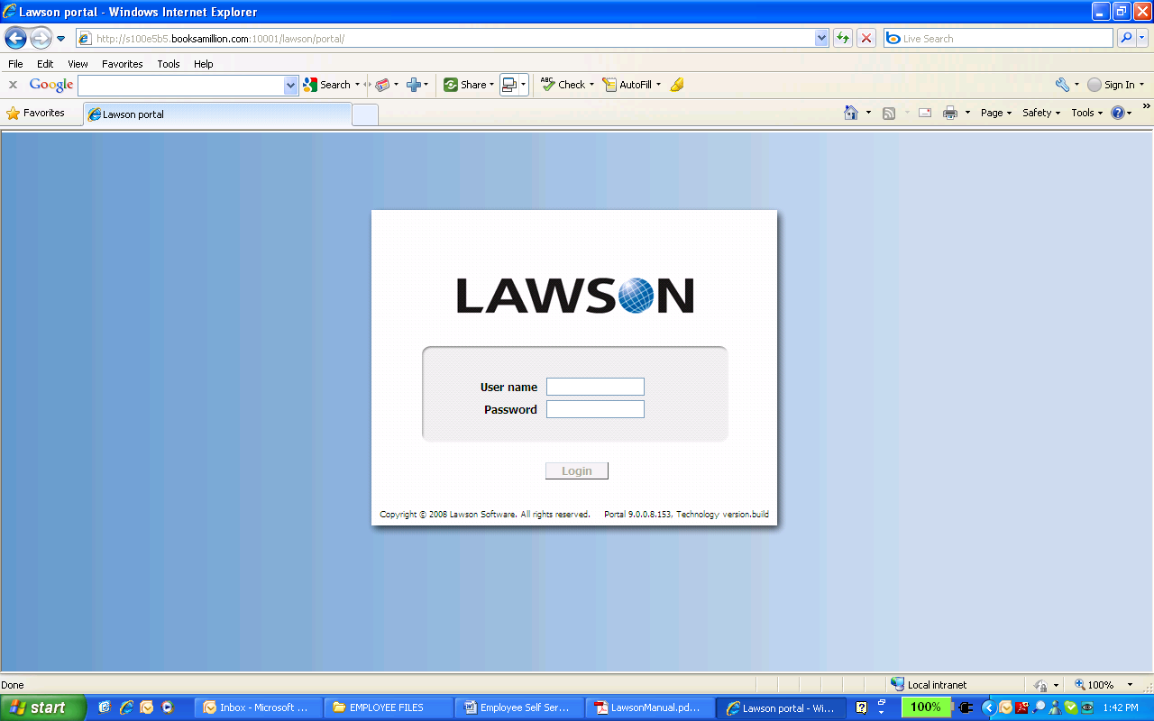

Remember that User IDs and Passwords are case sensitive. Make sure that the **CAPS LOCK** key on your keyboard is not engaged.

**Lawson Navigation**

**Process Basics**

This section includes the basic information required for a user to navigate the

Lawson system.

**Completing the Process**

􀂅 The Lawson home page is the first page that appears after you log in.

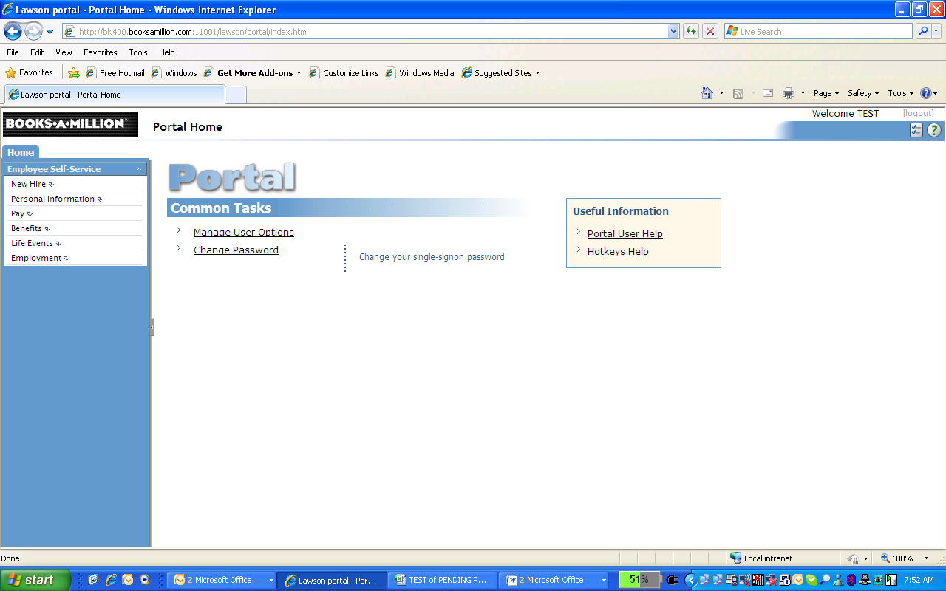

The left side of the Lawson screen contains Navigation elements including links

to various pages.

**Navigation List**

The Navigation List is on the left side of the Lawson screen.

Anytime you want to return to the main menu, click **HOME** or **PARENT MENU**.

**Status Bar**

The Status bar is the left side of the area across the bottom of the Lawson

screen. It is essential to constantly view this area of the system. The Status bar

reveals the system status, including error messages, at all times. If an error

message that you do not understand appears in the Status bar, ***stop***.

Determine the meaning of the error before continuing.

Log out using the option in Lawson!

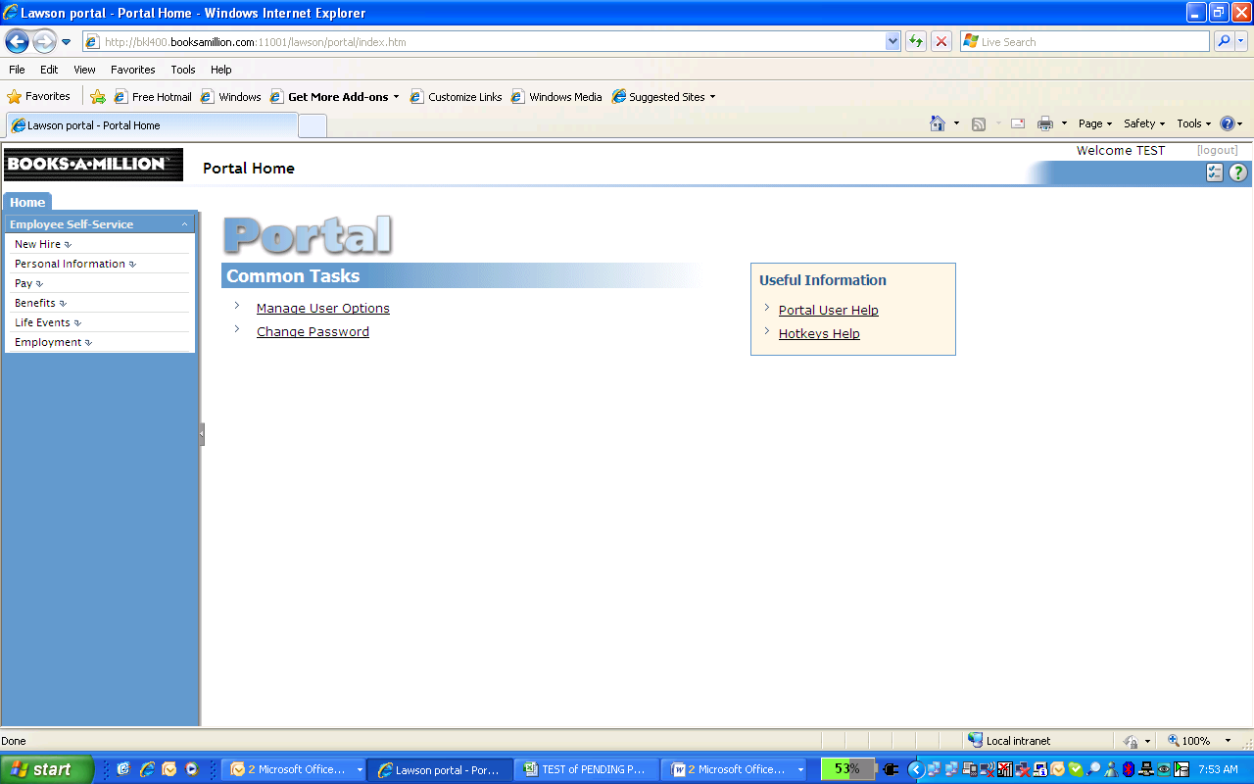

**Entering Changes and Updates**

[](http://willscullypower.files.wordpress.com/2009/12/tips.jpg)Once information is entered, the updated data will be sent to the appropriate department (benefits/payroll/etc).

**Logging Out**

􀂅 To log out of Lawson, click ‘(logout)’ in the top right of the window beside your name.

Do not use the Internet Explorer navigation tools when accessing Lawson. Using the Back, Forward, and other Internet Explorer buttons could result in the loss of

data entered on a Lawson form.

NEW HIRE

* This screen will allow you to set up each facet of your personal information when new to the company.
* Each element will open up further into more specific information fields related to that topic.

Payment Setup with Direct Deposit is listed as an example:

Click Payment Setup

Click Direct Deposit

Click Add

Click I AGREE WITH STATEMENT

Enter information

Click Update

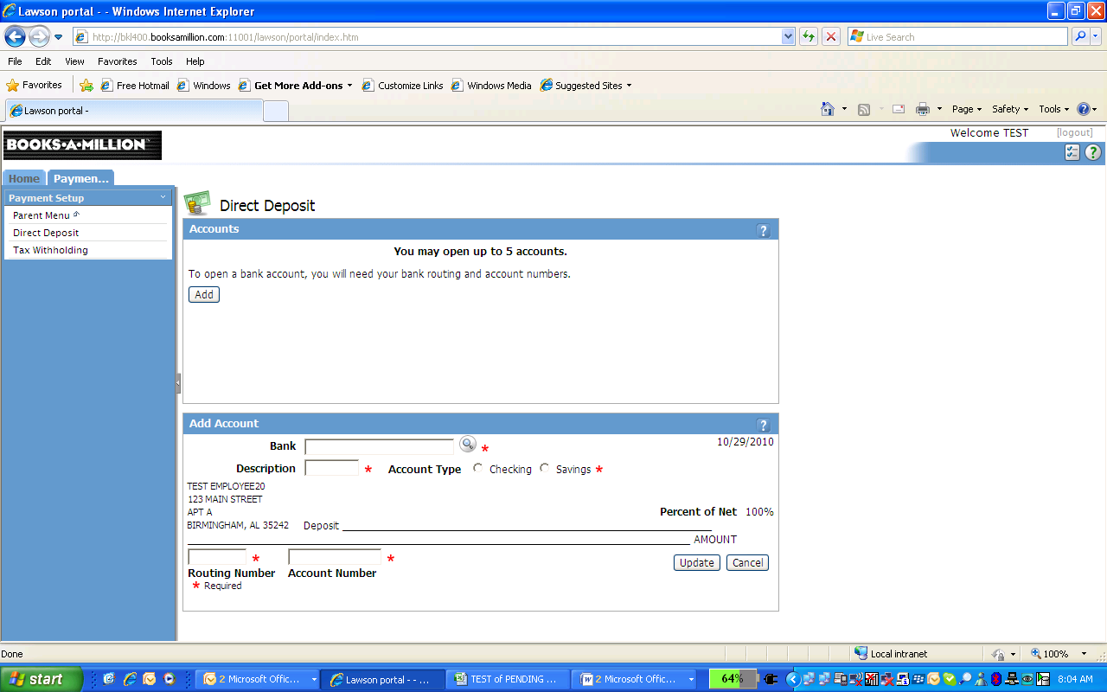

[](http://willscullypower.files.wordpress.com/2009/12/tips.jpg)Direct Deposit, Tax Withholding elections, Dependent information, and Beneficiary information can be entered on multiple screens/sections. The data will automatically fill in the other options regardless of which screen you choose to complete.

[](http://willscullypower.files.wordpress.com/2009/12/tips.jpg)Be sure to include all Dependent information.

Once Dependents are added, you cannot delete them.

PERSONAL INFORMATION

This screen allows you to review and update data associated with you!

You may:

Review and add Dependents

Review and add Emergency Contact Info

Review Personal Profile

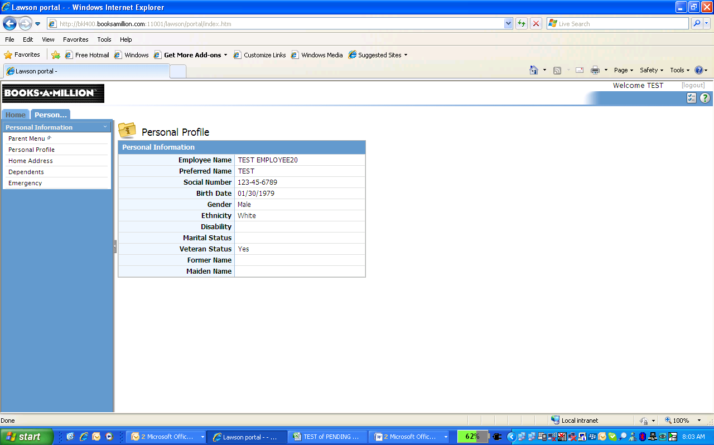

PAY

This screen allows you to review/update all data associated with pay

You may:

Update Direct Deposit info

Review Paycheck Stubs and history

Review Pay Rate History

Review and Update Tax Withholding information

Review Year To Date information

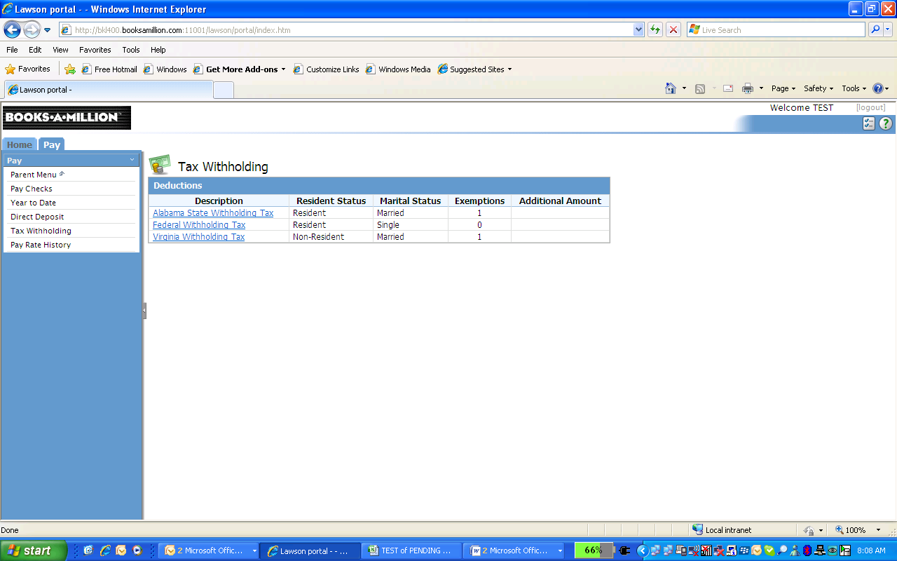

BENEFITS:

[](http://willscullypower.files.wordpress.com/2009/12/tips.jpg)New Hires should enroll in Benefits using the New Hire link on the Parent Menu.

Those experiencing a qualifying event (such as marriage, divorce, loss of other insurance, childbirth or adoption) should make changes to Benefits using the Life Events link on the Parent Menu.

**Beneficiaries**:

To add a beneficiary:

clickAdd Beneficiary

enter information

clickUpdate

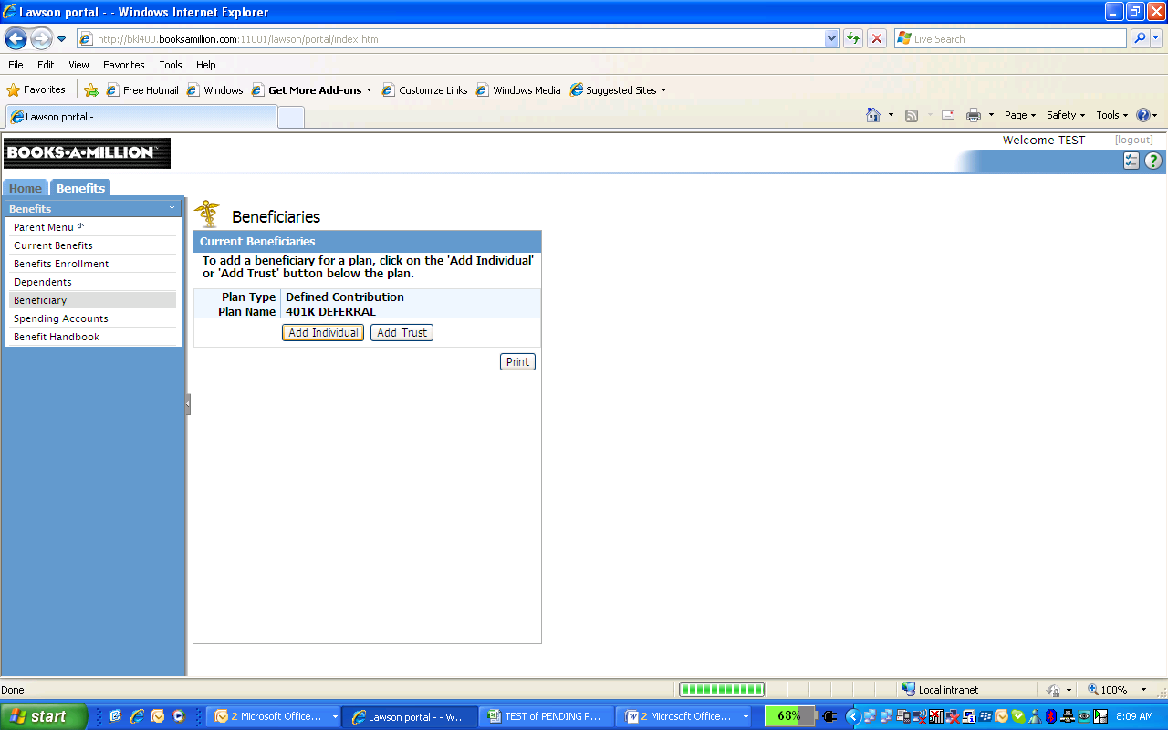

**Benefits Handbook**:

An updated version of the benefits handbook is available online at the link provided to the left labeled 2013 Benefits Guide.

**Benefits Enrollment:**

The Benefits Enrollment link may be used only during the schedule noted on page 4 of the 2010 Benefits Guide and benefits will take effect the first of the following month.

The “Benefits Enrollment” link should be used to enroll in benefits within 30 days of the occurrence of the following events:

* + Status Change: from part-time to full-time
  + Status Change: from full-time to part-time

Employees who do not have a qualifying event should use the “Benefits Enrollment” link to manage the following benefits only (all other benefits changes/elections will be denied):

* + [Payroll Savings (from January thru September only)](http://service.booksamillioninc.com/policies/Benefits/Savings/Enrollment_Form.pdf)
  + [AAF Deductions](http://service.booksamillioninc.com/policies/Benefits/Associate_Assistance_Fund/Enrollment_or_%20Change_Form.pdf)
  + [401k Deferrals](http://service.booksamillioninc.com/policies/Benefits/401k/Enrollment_Form.pdf)
  + [Company Stock (deduction decreases or stops only)](http://service.booksamillioninc.com/policies/Benefits/Bam_Stock_Purchase/Withdrawal_Form.pdf)

 Outside the Benefits Enrollment time period you will receive the error below.

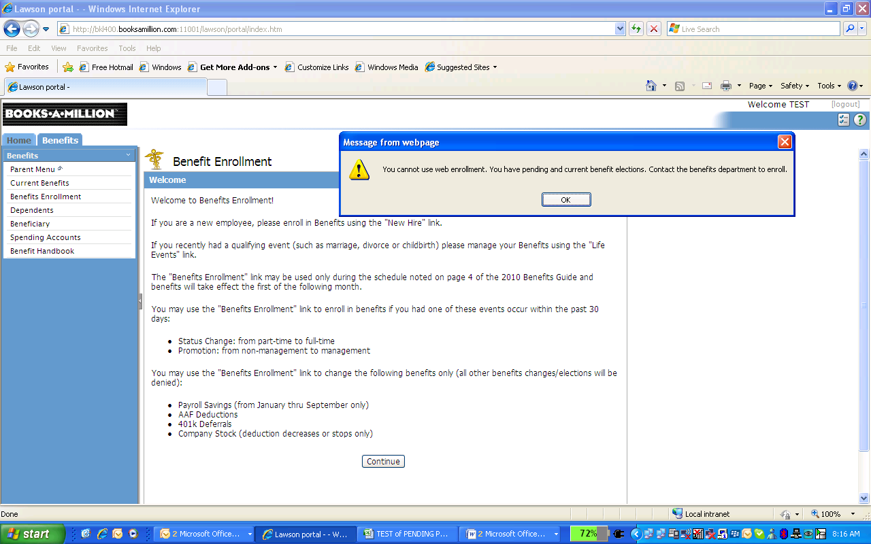

**Dependents**:

* On this screen you may add a dependent.
  + Click Add
  + Complete information
  + Click Update
*  You cannot delete a dependent once added

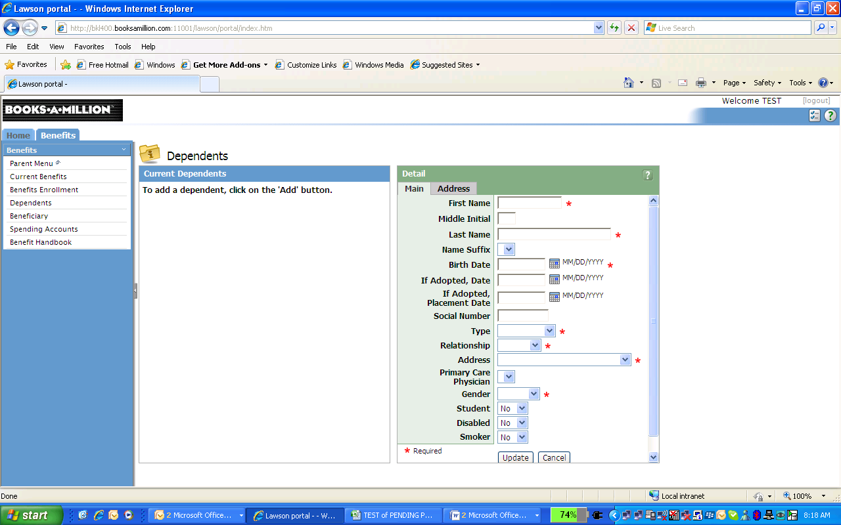

**Spending Accounts:**

If you are enrolled in a Spending account (HCA or FSA), this screen allows you to monitor your annual contributions associated with those accounts.

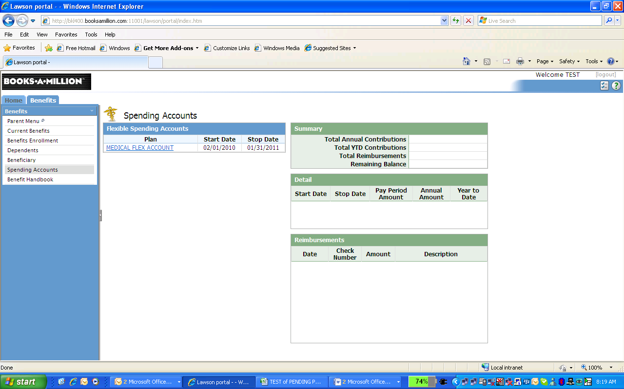

LIFE EVENTS:

Many events allow you to change or update your benefit elections. As you choose the appropriate event, the system will move you through the applicable steps.

On this screen you may enter information pertaining to the elements listed on the left (and in the screen):

Enter the information

Click Update

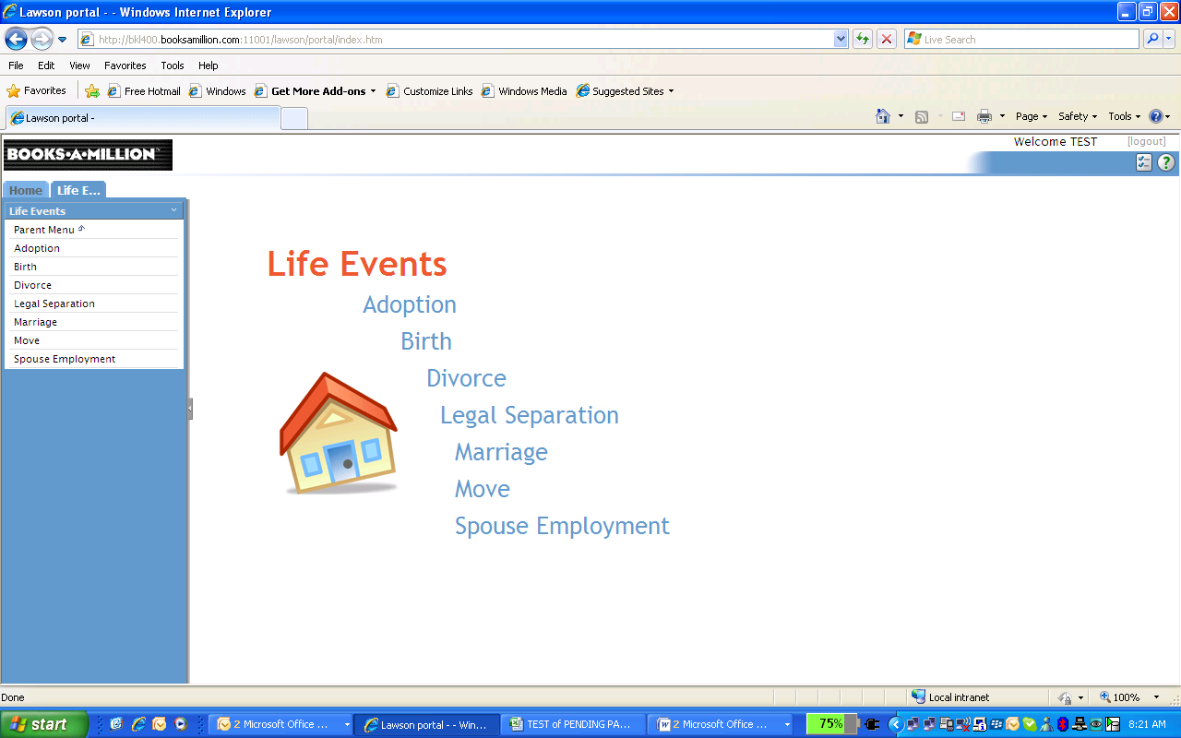

EMPLOYMENT:

**Job Profile:**

Here you may review your current position specific information, including:

Title, Job Code, Supervisor, Work Phone number, Hire Date and Pay Rate.

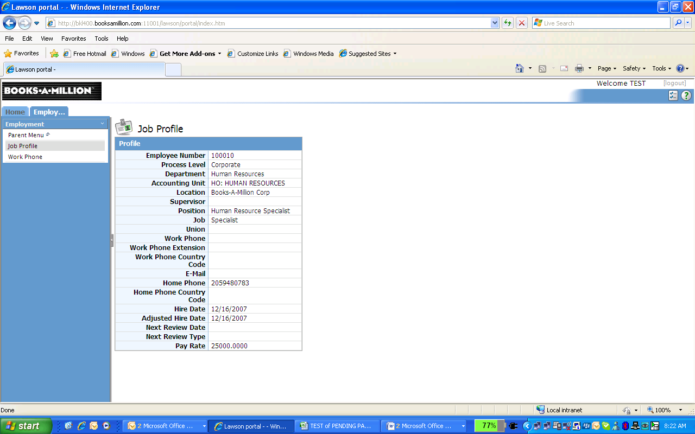

[](http://willscullypower.files.wordpress.com/2009/12/tips.jpg)To update:

Work Phone: go to WORK PHONE and enter information (see example below)

Home Address: go to LIFE EVENTS, then MOVE and enter information

Home Phone: go to LIFE EVENTS, then MOVE and enter information

Email address: go to WORK PHONE and enter information

You will not be able to update any elements related to your specific position or job. Should you have questions, please contact your Supervisor.

Please open an electronic copy of this manual from the BAM! website

(<http://policywiki.booksamillion.com/index.php?title=Policies_and_Procedures> ) to ensure that you have the latest version of all documentation.

*Lawson Software:* This manual is designed for Lawson Version 9

*Minimum Software Requirements:*

Microsoft® Windows 98 Operating System, Internet Explorer 6 browser, and

Lawson™ Portal.

*Disclaimer:* Books-A-Million, Inc *(*BAM!) takes care to ensure the accuracy and quality of these materials. Information herein is subject to change. Revisions may be issued. To

ensure the latest version of all documentation, please open an electronic copy

from the BAM! website. Data files for this manual are fictitious. Any resemblance to actual data is

coincidental.

*Trademark Notices:* All product names and services are common law or

registered trademarks and service marks of their respective companies. Use of

another entity’s product name or service in this manual is for editorial purposes

only. No such use, or the use of any trade name, is intended to convey

endorsement or other affiliation with the manual.

This manual is not to be reproduced for any reason without express written consent of the Books-A-Million, Inc., 402 Industrial Lane, Birmingham, AL 35211.

If you have questions, please call BAM Human Resources Department at (205) 942-3737.

**HELP DESK**: The help desk number is 205-909-9902.